DEFCON CTF
Writeup Repository
Author: Hohin.J
April 18, 2026

Introduction
This document contains detailed writeups for the challenges I solved during DEFCON CTF. Each writeup includes step-by-step analysis, tools used, and the methodology employed to capture the flag.
The writeups are organized by category and difficulty level, providing a comprehensive record of the problem-solving approaches and techniques utilized during the competition.

Beginner Challenges

Challenge: hidden
Category | Beginner
Difficulty | Easy (50 points)
Author | minato500
Files | challenge.txt
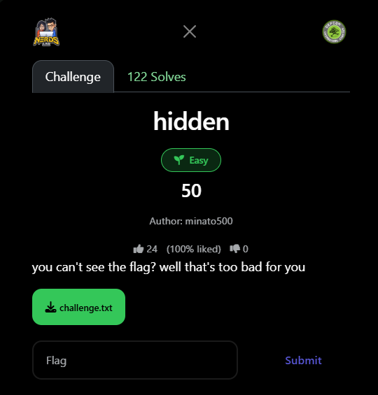

Description
Challenge description: "you can't see the flag? well that's too bad for you"

Analysis
Upon initial inspection, the challenge file challenge.txt appeared to contain normal text about Minato Namikaze from the Naruto series. There was no immediately visible flag in the content.
Key observations:
- The file contained normal-looking text (Naruto content)
- No visible flag was present in the text
- The challenge title "hidden" suggested data concealment
- The description hinted at invisible or hidden content

Solution
Step 1: Inspect Raw File
I used PowerShell to view the file in hexadecimal format to reveal any hidden characters:
Get-Content "$HOME\Downloads\challenge.txt" -Raw | Format-Hex
This revealed hexadecimal patterns:
00000000 20 09 09 20 20 09 20 20 09 20 09 20 09 09 20 20 09 09...
The presence of 20 (hex for space) and 09 (hex for tab) in patterns indicated whitespace steganography.

Step 2: Identify Encoding Scheme
- 20 (hex) = Space character
- 09 (hex) = Tab character
- These characters were not random but formed a deliberate pattern

Step 3: Extract Hidden Data
Used PowerShell to remove all characters except spaces and tabs:
(Get-Content "$HOME\Downloads\challenge.txt" -Raw) -replace '[^\t ]'

Step 4: Convert to Binary and Decode
The encoding scheme used:
- Space = 0
- Tab = 1
I created a Python decoder script:
#!/usr/bin/env python3 # Read the challenge file with open('challenge.txt', 'r') as f: lines = f.readlines() # Extract lines with only whitespace whitespace_lines = [] for line in lines: stripped = line.rstrip('\n\r') if stripped and all(c in ' \t' for c in stripped): whitespace_lines.append(stripped) print(f"[+] Found {len(whitespace_lines)} encoded lines") # Decode: tab=1, space=0 binary_string = "" for line in whitespace_lines: for char in line: if char == '\t': binary_string += '1' elif char == ' ': binary_string += '0' # Convert binary to ASCII decoded_message = "" for i in range(0, len(binary_string), 8): byte = binary_string[i:i+8] if len(byte) == 8: decoded_message += chr(int(byte, 2)) print(f"[+] Flag: {decoded_message}")

Step 5: Execute and Retrieve Flag
Running the decoder:
python decode.py
Output:
[+] Found 3 whitespace-encoded lines [+] Binary string length: 352 bits [+] Flag: defcon{s3cr3t5_4r3_h1dd3n_1n_th3_wh1t3sp4c3}

Flag
defcon{s3cr3t5_4r3_h1dd3n_1n_th3_wh1t3sp4c3}
The flag itself is a playful message: "secrets are hidden in the whitespace" - perfectly describing the solution method!

Key Takeaways
- Always check for hidden data: Use hex editors or commands to reveal non-printable characters when dealing with steganography challenges
- Whitespace steganography is common: Tabs and spaces can encode binary data invisibly in plain text files
- Challenge hints matter: The title "hidden" and description "you can't see" strongly suggested looking for invisible characters
- Standard binary encoding: Tab=1, Space=0 is the common convention, with 8 bits per ASCII character

Tools Used
- PowerShell: Get-Content and Format-Hex for file inspection
- Python 3: Custom decoder script for whitespace steganography
- Text Editor: Initial file analysis and examination

Future Challenges
Additional writeups for other DEFCON CTF challenges will be added to this document as they are completed. Categories will include:
- Cryptography
- OSINT (Open Source Intelligence)
- Web Exploitation
- Forensics
- Binary Exploitation (PWN)
- Reverse Engineering
- Miscellaneous

